|  |  |  |  |
| --- | --- | --- | --- |
| Angol szóbeli vizsga | Középszint | 1.Vizsgafeladat | Bevezető interjú |

**1. Vizsgafeladat -vizsgáztatói példány**

**Bevezetés (nem értékeljük)**

Mielőtt a tényleges szóbeli vizsga elkezdődik, egy rövid (kb. egyperces) bemelegítő beszélgetés szükséges.

Vizsgáztató:

* Did you sleep well?
* How are you today?
* What did you do yesterday evening?
* When did you get up?
* Is it the first time you are taking an exam?
* How did you come here?
* Are you planning to have a party after the exam?
* ( If “no”: ) What are you going to do after the exam?

*Now I am going to ask you a few questions. If you can’t understand me, I can repeat the question once. Let’s get started:*

**Tényleges vizsga (ettől a résztől értékeljük):**

Vizsgáztató:

We are going to talk about illnesses.

A What are the most common illnesses in Hungary?

**The common illnesses are: cold, flu. There are fatal diseases as well, for example: cancer and heart attack.**

B What can people do when they become ill?

**When people are ill they can cure themselves or go to the doctor’s. They can buy some medicine at the chemist’s. They can stay at home, relax, drink some hot tea.**

C When were you last ill? What were the symptoms?

**I was ill last winter. I had a high temperature, I had a flu, my nose was running and I had a sore throat. I had a bad cough.**

Thank you very much.

That’s the end of your first task.

ANGOL SZÓBELI VIZSGA KÖZÉPSZINT 2. VIZSGAFELADAT SZITUÁCIÓS FELADAT

2. VIZSGAFELADAT – VIZSGÁZTATÓI PÉLDÁNY

A vizsgáztató átadja a vizsgázónak a feladatlapot. A vizsgázó kb. fél percig készülhet.

# A VIZSGÁZÓ PÉLDÁNYA

You bought a new smart phone in a shop. When you wanted to use it for the first time, the Bluetooth was not working. You take it back to the shop and make a complaint. You have the receipt, but you can’t find the guarantee.

Include the following points:

* describe the problem with the smart phone
* point out the difficulties the problem caused you
* tell the shop assistant what kind of compensation you want

Your examiner will take the part of the shop assistant.

Prompts for the interlocutor:

Prompts for the interlocutor:

* Good morning, sir/madam. Can I help you?
* **Good morning. I bought this smart phone yesterday, but it isn’t working now.**
* What is the problem with the smart phone?
* **The Bluetooth is not working.**
* I’m really sorry about that. Could I have the receipt and the guarantee?
* **The receipt is here but I can’t find the guarantee.**
* I see. The receipt will do.
* **Could you exchange the smart phone for another one?**
* Please, wait a minute. I’ll see what I can do for you. Maybe I can exchange it for another smart phone, if we still have the same in stock. … I’m sorry, we don’t have any of this kind of phone.
* **If you don’t have it in stock, can you repair it, please?**
* I’m afraid that is not possible, sir/madam. It can’t be repaired.
* **Is it possible to get a refund?**
* All right. I’ll give you a refund, but in that case you’ll have to fill in a form for us first.
* **Does it take much time?**
* No, just a few minutes. Here you are.
* **Thank you.**
* Thank you.

|  |  |  |  |
| --- | --- | --- | --- |
| Angol szóbeli vizsga | Középszint | 3.Vizsgafeladat | Önálló témakifejtés |

#### **3. Vizsgafeladat - vizsgáztatói példány**

A vizsgáztató átadja a vizsgázónak a vizsgázó feladatlapját. A vizsgázó kb. fél percig készülhet.

# A vizsgázó példánya

These pictures show different hobbies. Compare and contrast the pictures. Include the following points:

- differences between the activities

- the necessary equipment

- your personal opinion of these activities

- your own hobbies

**In the first picture you can see a couple folk dancing, in the second picture you can see a man fishing. Fishing is a lonely activity, dancing is a group activity.**

**If you want to folk dance you need special clothes, some music. Boys wear a hat, boots, women wear a lot of skirts.**

**If you want to go fishing you need a fishing rod, a net, a bucket, some baits and a chair.**

**I like…**

**I don’t like…**

**In my free time I …**

**Prompts for the interlocutor:**

* How do you usually spend your free time?
* What do you need for doing these hobbies?
* Is your hobby similar or completely different from these activities?
* What new hobby would you like to take up? Why?

**THANK YOU, THIS IS THE END OF YOUR EXAMINATION.**

Melléklet: 3.1

**K 3.1**

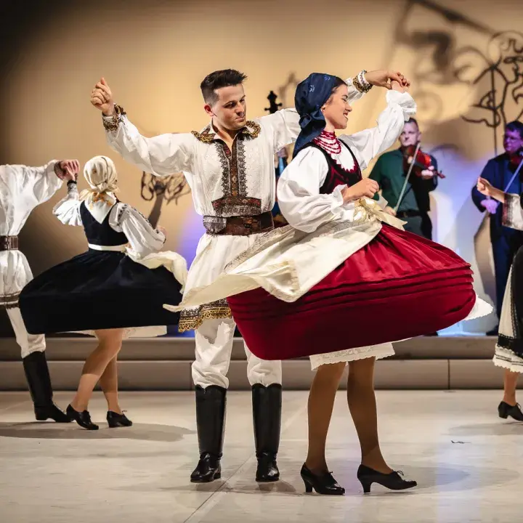

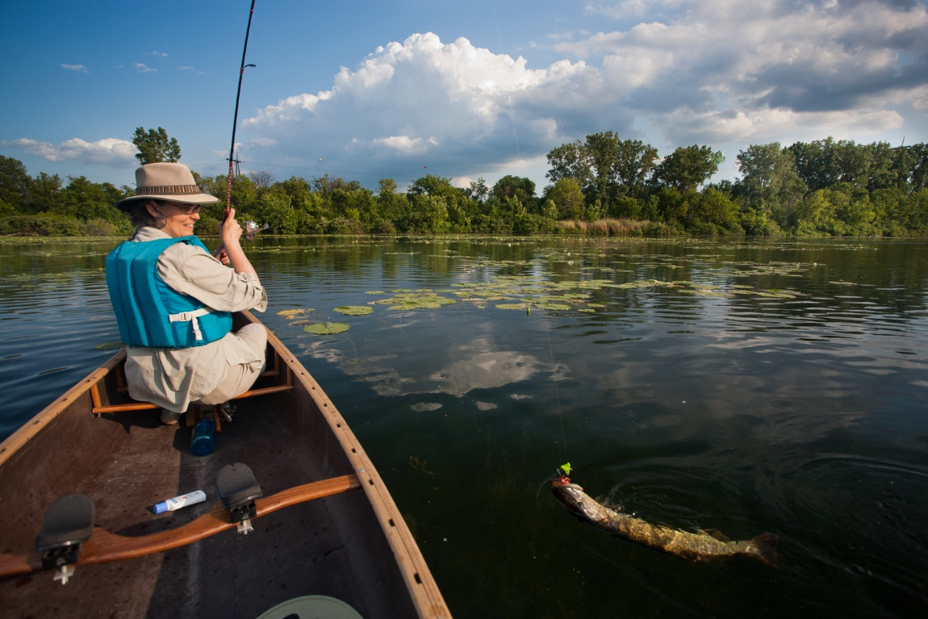

|  |  |  |  |
| --- | --- | --- | --- |
| Angol szóbeli vizsga | Közép szint | 2.Vizsga feladat | Szituációs feladat |

# A VIZSGÁZÓ PÉLDÁNYA

You bought a new smart phone in a shop. When you wanted to use it for the first time, they Bluetooth was not working. You take it back to the shop and make a complaint. You have the receipt, but you can’t find the guarantee.

Include the following points:

* describe the problem with the smart phone
* point out the difficulties the problem caused you
* tell the shop assistant what kind of compensation you want

Your examiner will take the part of the shop assistant.

|  |  |  |  |
| --- | --- | --- | --- |
| Angol szóbeli vizsga | Középszint | 3.Vizsga feladat | Önálló témakifejtés |

#### **3. Vizsgafeladat - vizsgázói példány**

# A vizsgázó példánya

These pictures show different hobbies. Compare and contrast the pictures. Include the following points:

- differences between the activities

- the necessary equipment

- your personal opinion of these activities

- your own hobbies

**K 3.1**

